Enhanced behavioural and neural sensitivity to punishments in chronic pain and fatigue

Flavia Mancini *
1
, Pranav Mahajan2
, Anna a V. Guttesen ´
1,2, Jakub Onysk1,3
3 , Ingrid
Scholtes4,5, Nicholas Shenker4
, Michael Lee5
, and Ben Seymour2,6
4
1
5 Computational and Biological Learning Unit, Department of Engineering, University of Cambridge,
6 Cambridge CB2 1PZ, UK
7
2Wellcome Centre for Integrative Neuroimaging, FMRIB, Nuffield Department of Clinical Neurosciences,
8 University of Oxford, Oxford OX3 9DU, UK
3
9 Applied Computational Psychiatry Lab, Max Planck Centre for Computational Psychiatry and Ageing
10 Research, Queen Square Institute of Neurology and Mental Health Neuroscience Department, Division of
11 Psychiatry, University College London, UK
4
12 Cambridge University Hospital, Cambridge, UK
5
13 Department of Medicine, University of Cambridge
6
14 Institute of Biomedical Engineering, University of Oxford

ABSTRACT

Chronic pain and fatigue in musculoskeletal disease contribute significantly to disability, and recent studies suggest an
association with reduced motivation and excessive fear avoidance. In this behavioural neuroimaging study in chronic
inflammatory arthritis participants and healthy controls, we aimed to identify the specific behavioral and neural changes
associated pain and fatigue during reward and loss decision-making. Computational modeling of behaviour identified a
parametric signature, characterized most notably by increased punishment sensitivity. This signature is distinct from patterns
previously reported in psychiatric conditions and it aligns with predictions of mechanistic models of chronic pain such as the
fear avoidance model. Neural activity associated with the punishment prediction error was enhanced in the right posterior
insular cortex, putamen, pallidum, and dorsolateral prefrontal cortex. Functional network connectivity analysis showed that
insula centrality correlated with subjective reports of fatigue and pain. Overall, the findings show that pain and fatigue in chronic
pain relate to objective behavioural changes, and can be mapped to a specific pattern of activity in brain circuits of motivation
and decision-making.

1 INTRODUCTION

Chronic pain and fatigue are the cardinal symptoms of musculoskeletal disease and lead to a level of disability that has significant socioeconomic cost (Woolf and Pfleger, 2003). Although multiple factors may contribute to the risk of developing chronic pain, a key hypothesis is that reduced central motivational drive to engage in physical activity leads to physical deconditioning that in turn exacerbates pain, a corollary of the fact that physiotherapy is clearly beneficial in most subacute and chronic musculoskeletal conditions (Meulders, 2019; Vlaeyen et al., 2016). This ‘fear avoidance’ hypothesis links to other neurobiological and cognitive factors known to contribute to risk for pain chronification, embedded within the broader biopsychosocial model that captures the complexity of chronic pain in everyday clinical contexts (Gatchel et al., 2007). The mechanism by which pain reduces central motivation therefore represents a critical link in the pathway to chronic pain and fatigue development (Seymour et al., 2023), but its nature and neurobiology are not known.

Injuries are common across animal species, for example after accidents and within/cross species contests, and lead to recognisable protective and recuperative behaviours (Walters and Williams, 2019). These are presumed to be evolutionarily adaptive because the injured state makes animals more vulnerable to further harm, and so being extra careful whilst recovering benefits survival (Walters, 1994). Peripheral and spinal sensitization to pain provide one route to hyper-protective behaviour, and excessive pain hypersensitivity is a key focus of many current models of chronic pain. But recent ecological studies indicate a broader hyper-sensitivity to threat that goes beyond pain, suggesting a central, supramodal enhanced sensitivity to punishments as a mechanism of behavioural homeostasis after an injury, and a potential contributing factor to chronic pain and disability (Lister et al., 2020). Whilst enhanced punishment sensitivity would be adaptive for simple musculoskeletal injuries encountered in ecological contexts, it would ultimately be maladaptive in the context of clinical musculoskeletal conditions where inactivity is detrimental (Seymour et al., 2023).

Computational models of the neural circuits of learning and motivation allow us to dissect its core information processing steps, thus helping identify the underlying components of post-injury homeostasis such as modulation of punishment sensitivity (Seymour and Mancini, 2020). A similar approach has been applied to human behavioural experiments to identify, for example, reduced reward sensitivity in major depressive disorder, and aversive generalisation in anxiety disorder (Aylward et al., 2019; Huys et al., 2013; Dunsmoor and Paz, 2015). In this study, we aimed to identify i) whether there is a specific behavioural signature of pain and fatigue manifest during reward and loss decision making, and ii) if there is, does it relate to specific, localisable activity in the brain, in particular in circuits associated with motivation and learning.

Reward and loss decision-making captures a fundamental process that underlies much of our everyday behaviour - doing things that benefit us, and avoiding things that don’t. We studied this using a ’4-armed bandit’ task (figure 1; (Daw et al., 2006; Seymour et al., 2016; Aylward et al., 2019)). Computational modelling of behavioural data can then be used to interrogate brain activity to find corresponding neural processing steps, and their relation to pain and associated fatigue. In the human brain, the mesolimbic and insula regions are thought to play a key role in pain-related motivation and avoidance learning, alongside a broader role in behavioural homeostasis (e.g. in illness and sickness states (Uddin et al., 2017)). We reasoned that the insula in particular might link the physiological identification of injury with enhanced responsiveness to punishments, which ultimate contribute to the pain and fatigue phenotype.

- Corresponding author: flavia.mancini@eng.cam.ac.uk

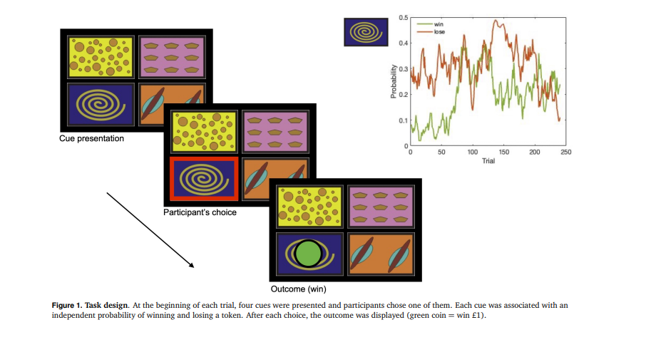

2 RESULTS

2.1 Choice behavior

We recruited 60 volunteers to a behavioural neuroimaging experiment: 30 patients with painful inflammatory, and 30 age and sex matched controls (see Methods). In the 4-armed bandit task, participants were presented with four cues, and they need to choose one of them on each trial. Each cue was associated with an independent, non-stationary probability of winning or losing a coin worth £1. The mean reward and punishment rate were independent of each other, and noisy - slowly changing across trials (as a Gaussian random walk). After selecting one of the cues, their choice yielded one of four possible outcomes: one green token (win £1), one red token (lose £1), one green and one red token (win £1 but lose £1, so effectively £0 when added at the end of the game), and no outcome. This nature of the task means that participants need to constantly learn about the outcomes, with each option being fully independent of others, and importantly to learn independently about rewards and losses (i.e. so we can dissociate differences in reward and loss learning).

Basic performance measures (net gains, reaction times, frequency of choice switches) were comparable between patients and controls (see Supplementary Behavioural Results). This similar level of net gains is as expected: as the task is effectively a dynamic learning environment for probabilistic outcomes, different levels of performance do not yield big differences in outcomes, which protects against the potentially confounding effects of accruing different winnings. In contrast, any differences between groups is embedded in the trial-by-trial dynamics as a result of exploration and learning.

To capture these learning effects we used a hierarchical Bayesian inference approach to fit multiple variants of Reinforcement Learning (RL) models to the choice data, first to all pooled participants and then separately for the two groups (see Methods). These are biological informed models, arising from basic animal learning theory, that are known to capture behaviour and brain activity during this general class of task (Seymour and Mancini, 2020). The hierarchical Bayesian approach allows for individual differences while aggregating information across participants of the same group and make meaningful group comparisons (Ahn et al., 2017). The choice data of the pooled participants and of the patient group (Table 1) were best fitted by two models (Figure 1 and Figure 3) that included two sensitivity parameters for rewards and punishments, which were used to scale the prediction error, a lapse and a decay parameter capturing forgetting in choice behavior. In absolute terms, model 1 fitted best the data, but it was not significantly different than model 3. The only difference between models 1 and 3 lies in their learning rates: model 1 has two learning rates (alpha and beta) that were added for updating reward values (reward LR = α + β) and subtracted for updating punishment values (punishment LR = α - β), whereas model 3 has separate, fixed learning rates for rewards and punishments). In the control group, model 3 showed the best absolute fit, but it was not significantly different than the other models we tested.

We compared the group estimates of the parameters of model 1 between the arthritis patient group and the control group, to investigate any core underlying differences in choice behaviour. The group-level estimates of each free parameter of model 1 are reported in Table 2, and the individual participant’s estimates are shown in Figure 2. In keeping with our core hypothesis, participants with chronic arthritis were more sensitive to punishments when compared to controls. In addition, we also found that In addition, we also found that they had faster memory decay and greater lapses in the choice behaviour. Finally, the differential component of the learning rate (β) was also higher in patients.

Neural correlates of punishment PE, PPE

Participants performed the bandit task whilst undergoing functional brain MRI. We aimed to identify brain changes associated with the behaviourally manifest difference in punishment sensitivity. Since punishment sensitivity scales the magnitude of the value of the punishment as used for learning avoidance actions, this is reflected in brain responses correlated with the punishment prediction error (PPE), with the individually estimated punishment sensitivity as a covariate. Thus, we evaluated whether the neural activity associated with the PPE, and modulated by punishment sensitivity, differed across groups. The arthritis group showed increased activity in the right posterior insular cortex, putamen, pallidum, and dorsolateral prefrontal cortex (figure 3; table 3. There was no significant cluster of decreased activity, at the cluster threshold used (z>2.6, p<0.05). For completeness, common activity across the two groups is reported in Supplementary Figure S3 and Supplementary Table S6.

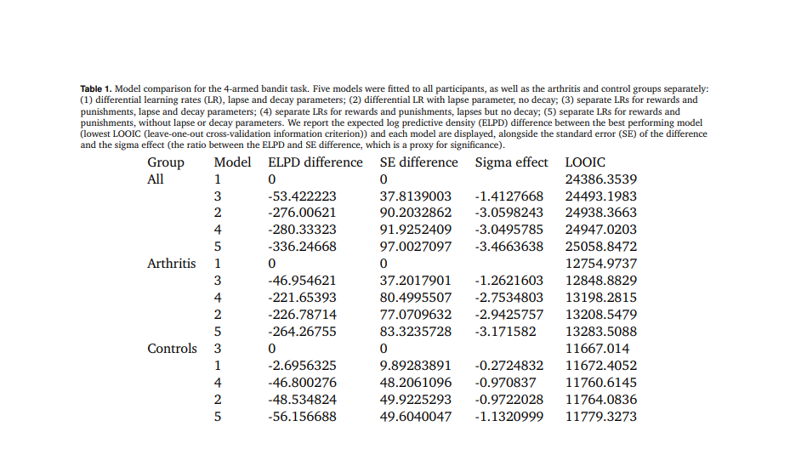
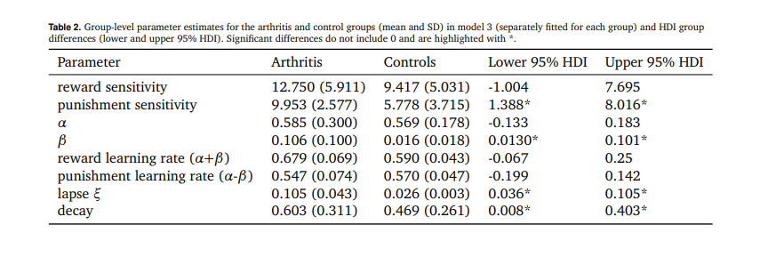
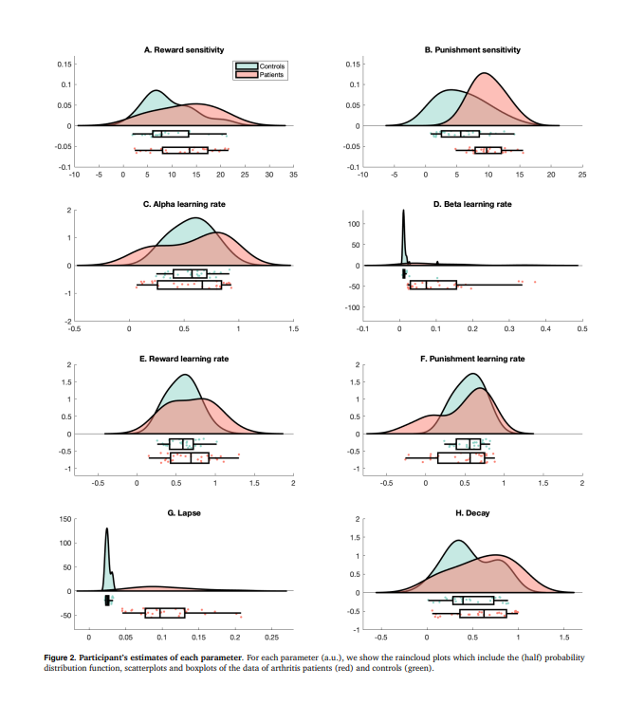
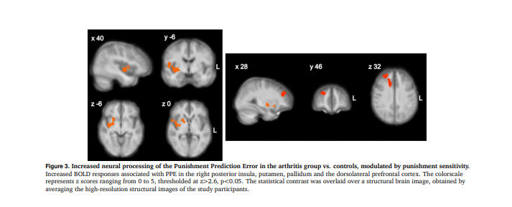

Neural correlates of reward PE, RPE

Rewards prediction error (RPE) activity modulated by reward sensitivity was decreased in arthritis participants vs. controls in the a rostral region of the paracingulate gyrus and neighbouring white matter, and increased in the left occipital fusiform gyrus, area V4 (table 4). There was no significant cluster of increased activity, at the cluster threshold used (z>2.6, p<0.05). Common activity across groups is reported in Supplementary Figure S4 and Table S7.

2.4 Connectivity analyses

The correlation of punishment sensitivity with evoked BOLD responses in the insula is in keeping with the core hypothesis that the insula is a central part of a behavioural homeostatic network that mediates motivational changes in the pain state. To look at this further, we aimed to identify whether the insula connectivity during the task correlates with pain behaviour and task parameters. To do this, we calculated the network centrality (here, degree centrality), which captures the importance or influence of the insula as a network hub during the task. We parcellated the brain into 180 symmetrical ROIs using a functional (Glasser) brain atlas, and constructed a binarised connectivity network using thresholded pairwise Pearson correlations (see Methods). This analysis ignores the task events, and simply considers overall connectivity during the task as a whole. We found that degree centrality in posterior insula subregions correlated with subjective reports of daily average pain and fatigue scores (see figure 5A). There was evidence for a correlation between Posterior Insular Area 2 and measures of pain (average daily pain rating from weekly diaires: diaries: Pearson’s r= 0.566, LogBF10= 3.413; BPI severity score: Pearson’s r= 0.544, LogBF10= 2.958), as well as fatigue (average daily fatigue rating from weekly diaries: Pearson’s r= 0.517, LogBF10= 2.468). These correlations were less apparent when performing the same analysis using the resting state fMRI data, which has also been observed in other connectivity analyses (Zhao et al., 2023) (figure 5B). This provides evidence that posterior insula activity not only correlates with pain related changes in objective task behaviour, but that it sits within a network of regions whose activity correlates with clinical subjective ratings of fatigue and pain.

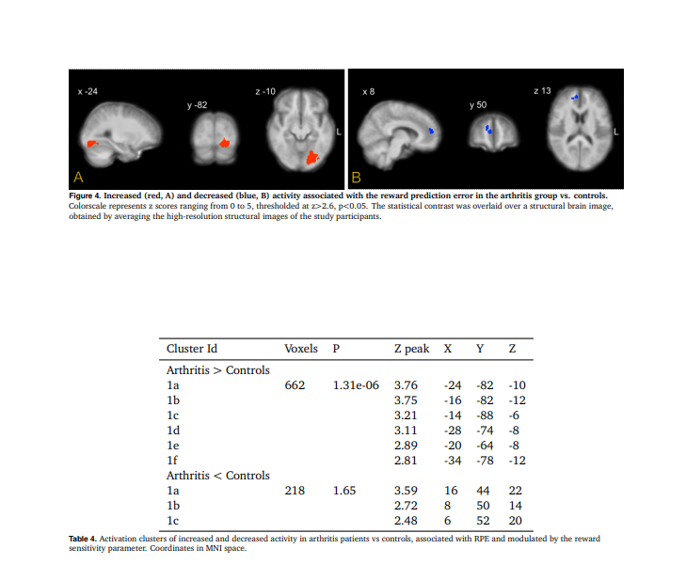

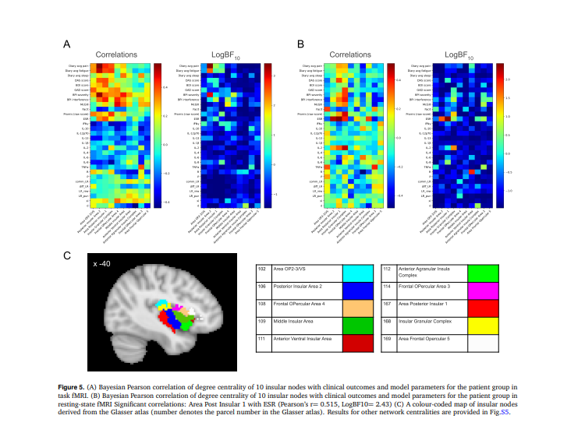

Figure 5. (A) Bayesian Pearson correlation of degree centrality of 10 insular nodes with clinical outcomes and model parameters for the patient group in task fMRI. (B) Bayesian Pearson correlation of degree centrality of 10 insular nodes with clinical outcomes and model parameters for the patient group in resting-state fMRI Significant correlations: Area Post Insular 1 with ESR (Pearson’s r= 0.515, LogBF10= 2.43) (C) A colour-coded map of insular nodes.

3 DISCUSSION

The results reveal specific computational signature of chronic pain and fatigue, reflected in the pattern of changes of the underlying parameters that govern motivated behaviour. At the heart of this signature is an increase in punishment sensitivity, which demonstrates a generalised form of hyper-protective behaviour that enhances learning of aversive outcomes and may lead to excessive avoidance. This allows the organism to enhance defence beyond transient pain, which can mediated by central and peripheral hypersensitivity, to other aversive outcomes.

4 OUTCOMES

4.1 Participants

We initially engaged approx. 15 local patients with chronic pain to help us design the study and iterated preliminary versions of the protocol using a systems engineering approach. The study was approved by the central NHS Health Research Authority ethics committee (REC: 17/SW/0113, IRAS: 216259). After the design was finalised, we screened 80 volunteers and recruited 30 patients with chronic rheumatoid and psoriatic arthritis and 30 healthy age-matched controls. Patients were recruited at Rheumatology, Cambridge University Hospitals. All participants gave informed written consent according to the Helsinki Guidlines. Three participants did not complete the full study and were therefore excluded, leaving us with 57 participants in total (28 controls and 29 patients; 45 females). Patients were 53.83 ± 8.09 years old (range 36-66 years; 27 females), and controls were 51.50 ± 10.77 years old (range 33-69 years; 18 females). Participants were screened with a non-standardized demographic questionnaire and the following: Beck Depression Inventory II, Brief Pain Inventory, McGill Pain Assessment, Functional Assessment of Chronic Illness Therapy Fatigue Scale, Short form PROMIS Sleep Scale. Trained staff carried out arthritis assessments with standardized joint assessment disease activity score (DAS), rheumatoid classification (ACR/EULAR criteria) and psoriatic classification. Patients with disease activity (DAS >2.6) or subjectively high fatigue scores (>4 on scale 0 = ‘no fatigue’ to 10 = ‘worst fatigue imaginable’, FACIT <35) were included in the study. Controls had no clinically significant disease activity (DAS <2.6) or subjective fatigue (<4 on scale 0 = no fatigue to 10 = worst fatigue imaginable, FACIT >30). Participants with other explanations on fatigue explanations for fatigue (anaemia, unstable thyroid, heart conditions, diabetes, recent cancer treatment, recent surgery) and contra-indications for MRI safety (WBIC safety questionnaire) were considered not eligible to the study. The demographic and clinical details of the participants who completed the study are reported in Supplementary Table 1.

4.2 Procedure

Participants took part in an initial screening and training session, and in a further MRI session. The two sessions were separated by 5-73 days, depending on participant, site and scanner availability.Throughout both sessions and tasks/runs, participants were asked to rate their fatigue and pain on a scale of 0 to 10 (0 = no fatigue/pain, 10 = worst fatigue/pain imaginable).

4.3 4-armed bandit task

Participants underwent a 4-armed bandit decision-making task during MRI, following some practice. In each trial, participants could choose between 4 abstract boxes presented on the screen and try to win green tokens and simultaneously but independently, try to avoid red tokens. The green and red signalled winning and loosing £1, respectively. The sum of positive minus negative tokens was exchanged for money at the end of the experiment. The probability of win/loss in each box changes gradually over trials as a gaussian random walk. The participants completed 240 trials over 4 runs.

4.4 Inflammatory markers

Blood samples were obtained for all participants in the second visit and the following inflammatory markers were evaluated: ESR, IFNγ, IL-10, IL-12p70, IL-13, IL-1β, IL-2, IL-4, IL-6, IL-8, TNFα. General health was assessed in full blood count and liver function samples.

4.5 Actigraphy and daily ratings

Participants recorded daily ratings and wore an ActiGraph GT9X Link (Actigraph, LLC) to the wrist, 24 hours a day, over the course of 5-7 days. The wearable device contains a piezo-electric sensor that generates a voltage when the device undergoes a change in acceleration (3 axial). It was set to record 60s epochs. Participants removed the wristbands only for showering or swimming. During this week, participants rated their fatigue and pain (“how much fatigue/pain do you feel right now on a scale of 0 to 10, 0 = no fatigue/pain, 10 = worst fatigue/pain imaginable). The participants set their alarms in the morning (9:00/9:30) and evening (19:30/20:00) and noted their current rating down on a questionnaire that was previously provided by the experiments. Participants also recorded their daily consumption of caffeine and alcohol on a questionnaire. They noted how many units were consumed and the details of the product (e.g. filter coffee, paracetamol, wine etc). Analysis and results of actigraphy is reported in the Supplementary Methods and Results document.

4.6 Modelling of choice behavior

We simulated and fitted five Reinforcement Learning (RL) models based on non-probabilistic delta rules, whereby the learning rates are fixed and driven by discrepancies between the estimate of the expected value

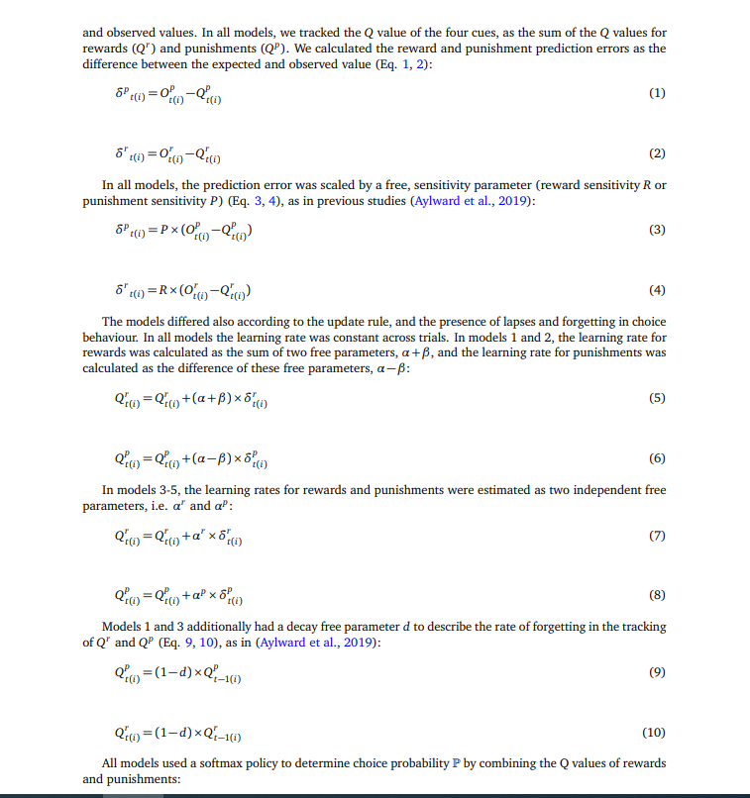
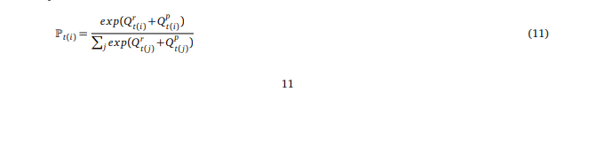
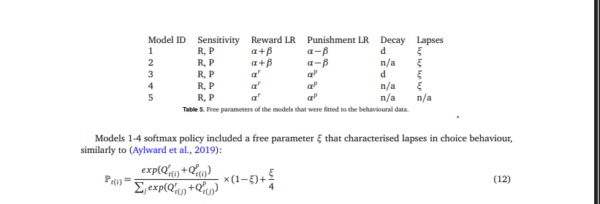

Table 5 summarizes the free parameters of the different models we simulated and fitted to the data. We used hierarchical Bayesian methods (Hamiltonian Monte Carlo) to estimate model parameters, with the HBayesDM and Stan package for R (Stan Development Team, 2019; Ahn et al., 2017) in R. For each model, we fit 4 chains with 1000 burn in samples and 2000 samples to the following data: choice (1:4), win (0,1), and loss (0,-1) for each trial.

Parameters for all models were fit separately for each group, as well as for all participants pooled in a common group. The winning model was defined as the model with the lowest Leave-One-Out Information (LOOIC). We also estimated the difference in models’ expected predictive accuracy through the difference in expected log-wise predictivity density (ELPD) (Vehtari et al., 2017). By taking the ratio between the ELPD difference and the standard error (SE) of the difference, we obatin the sigma effect, which is a heuristic for significance of such model differences.

We compared parameter estimates from the winning model across the two groups using 95 % high density intervals (HDI). In particular, for each comparison, we calculated the difference in the hyper parameters between groups and reported the 95% HDI of the difference.

In the Bayesian scenario, a significant group difference is indicated by the interval not containing the value 0.

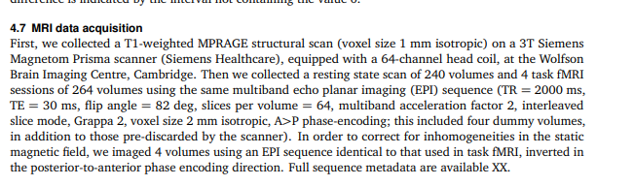

4.8 MRI Data Analyses

4.8.1 Preprocessing

The anatomical images were reoriented to standard orientation, automatically cropped and bias-field corrected using ’fsl_anat’ (FMRIB’s Software Library, www.fmrib.ox.ac.uk/fsl). The brain was extracted with ANTs tool ’antsBrainExtraction’ (https://github.com/ANTsX/ANTs). Functional images had the first four volumes removed, were motion corrected using FSL tool ’mcflirt’, 3D time shifted using AFNI program, ’3dTshift’ and a Fourier method (https://afni.nimh.nih.gov/). Fieldmap correction was applied using HySCO, Hyperelastic Susceptibility Artefact Correction (Ruthotto et al., 2013). Non-brain data were removed using FSL tool BET. Spatial smoothing was applied using a Gaussian kernel of FWHM 8.0mm. The entire 4D dataset was grand-mean intensity normalised by a single multiplicative factor and highpass temporal filtering was applied (Gaussian-weighted least-squares straight line fitting, with sigma = 50.0s) using FSL.

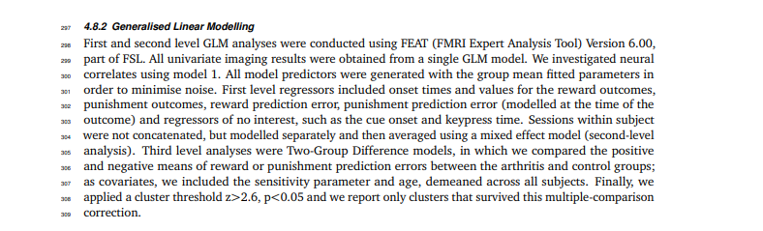

4.8.3 Connectivity analyses

Filtered functional images, preprocessed as per section 4.8.1 were registered to standard format (MNI template) and then parcellated into 180 regions of interest using the Glasser functional atlas (Glasser et al., 2016). Each region of interest combines the symmetric region of the brain, i.e. right and left regions jointly form one parcel. The timeseries for each parcel were extracted as the mean of the timeseries’ corresponding to all voxels in that parcel. This process was performed for all four runs of task-fMRI and one run of rest-fMRI, and we performed elementwise summation of the four task-fMRI timeseries runs, making it comparable with the rest-FMRI. Fully connected networks were constructed with edge strength between two nodes being the Pearson correlation between the timeseries corresponding to the nodes. We then thresholded the Pearson’s full correlation matrices to a produce binary adjacency matrix (consisting of 1’s and 0’s) for each participant, as well as done in our previous studies (Mano et al., 2018). Each of the correlation matrices was thresholded in an adaptive manner to produce an adjacency matrix with a 10% link density. This value was chosen based on previous network topology studies that have found such a link density to provide optimal discriminative ability (Mano et al., 2018; Achard et al., 2012; Itahashi et al., 2014; Mansour et al., 2016; Termenon et al., 2016). We then computed the following nodal centrality measures for parcels corresponding to insular sub-regions: degree centrality, eigen-vector centrality, betweenness centrality, closeness centrality and load centrality. The Glasser’s atlas, being a functional atlas, has several parcels, some of which may overlap with the anatomical insular region. . We found the Glasser parcels which correspond to the anatomical insula region by cross-checking the regions which intersect/overlap with the left and right insula regions in the AAL atlas, in FSLeyes.

5 DATA AND CODE AVAILABILITY

All code and data will be available open source, released upon acceptance of the paper.



REFERENCE

Achard, S., Delon-Martin, C., Vértes, P. E., Renard, F., Schenck, M., Schneider, F., Heinrich, C., Kremer, S., and Bullmore, E.T. (2012). Hubs of brain functional networks are radically reorganized in comatose patients. Proceedings of the National Academy on Sciences, 109(50): 20608-20613.

Ahn, W.-Y., Haines, N., and Zhang, L. (2017). Revealing neurocomputational mechanisms of reinforcement learning and decision-making with the hBayesDM package. Computational Psychiatry, 1:24–57.

Cole, R. J., Kripke, D. F., Gruen, W., Mullaney, D. J., and Gillin, J. C. (1992). Automatic sleep/wake identification from wrist activity. Sleep, 15(5):461–469.

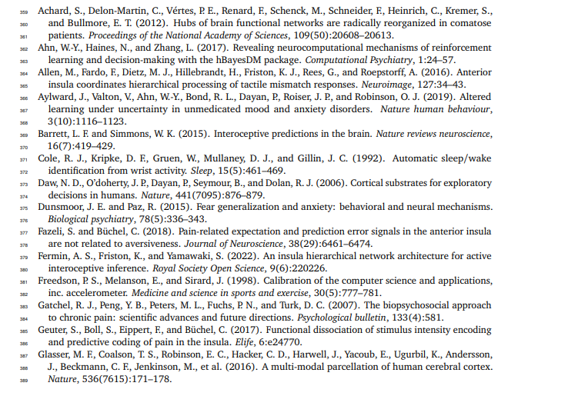
Gueguen, M. C., Lopez-Persem, A., Billeke, P., Lachaux, J.-P., Rheims, S., Kahane, P., Minotti, L., David, O., Pessiglione, M., and Bastin, J. (2021). Anatomical dissociation of intracerebral signals for reward and punishment prediction errors in humans. Nature communications, 12(1):3344.

Stefanov, K., McLean, J., McColl, A., Basu, N., Cavanagh, J., and Krishnadas, R. (2020). Mild inflammation in healthy males induces fatigue mediated by changes in effective connectivity within the insula. Biological Psychiatry: Cognitive Neuroscience and Neuroimaging, 5(9): 865-874.

Horing, B. and Büchel, C. (2022). The human insula processes both modality-independent and pain-selective learning signals. PLoS Biology, 20(5):e3001540.

Lister, K. C., Bouchard, S. M., Markova, T., Aternali, A., Denecli, P., Pimentel, S. D., Majeed, M., Austin, J.-S., Williams, A. C. d. C., and Mogil, J. S. (2020). Chronic pain produces hypervigilance to predator odor in mice. Current Biology, 30(15):R866-R867

Lister, K. C., Bouchard, S. M., Markova, T., Aternali, A., Denecli, P., Pimentel, S. D., Majeed, M., Austin, J.-S., Williams, A. C. d. C., and Mogil, J. S. (2020). Chronic pain produces hypervigilance to predator odor in mice. Current Biology, 30(5):R866-R867

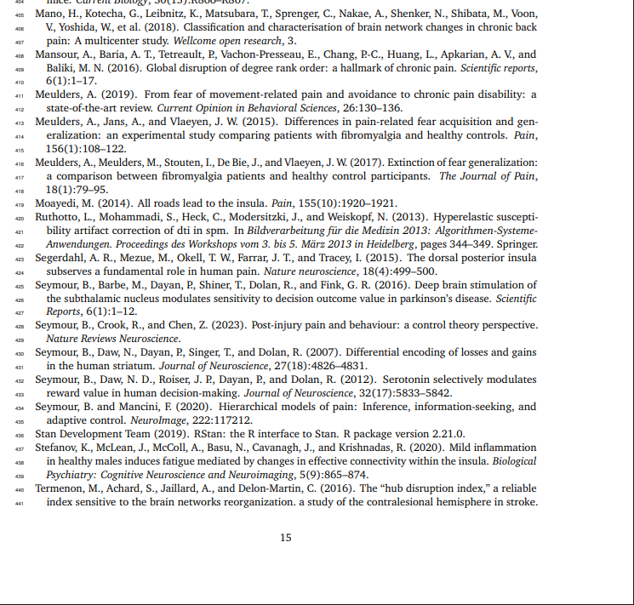
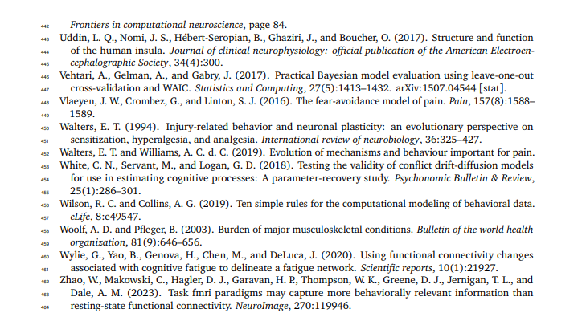
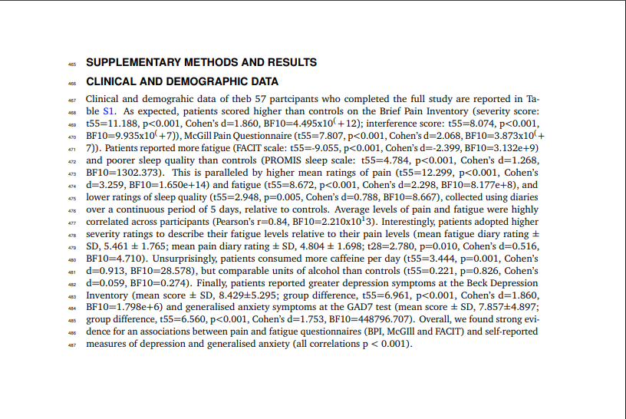

SLEEP ACTIGRAPHY

We used ActiLife v6.13.3 to extract sleep measures. Automatic detection of sleep periods was implemented with Tudor-Locke automatic sleep period detection. If there was a discrepancy of >2 hours between the automated detection timing and the self-documented bedtime or out-of-bed time, the self-documented times would be entered automatically as sleep periods. The Cole-Kripke algorithm was applied to the data to determine sleep parameters (Cole et al., 1992). Data from 5 participants (3 patients) with <5 nights of recording were excluded from further analyses, leaving 52 participants for analysis (25 patients). Controls and patients showed comparable results in the sleep parameters, total sleep time (t(50)=1.597, p=.117, Cohen’s d=0.443, BF10=0.788), movement index (t(50=-1.684, p=0.098, Cohen’s d=0.467, BF10=0.884), sleep fragmentation (t(50)=-1.648, p=0.106, Cohen’s d=0.457, BF10=0.842), sleep latency (t(50)=-0.296, p=0.768, Cohen’s d=0.082, BF10=0.289), sleep efficiency (t(50)=0.794, p=0.431, Cohen’s d=0.220, BF10=0.361) and wake-after-sleep-onset (t(50)=-0.171, p = 0.865, Cohen’s d=0.047,BF10=0.282).

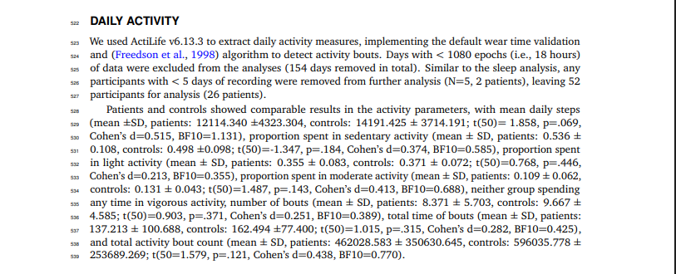

SUPPLEMENTARY MODELLING ANALYSIS

8.1 Parameter recovery

To asses the reliability of our modelling analysis (Wilson and Collins, 2019), for each model we performed parameter recovery analysis, where we simulated participants’ responses using newly drawn individual-level parameters from the group-level distributions, for each group and for a pooled dataset.

We then fit the same model to the simulated data and calculated Pearson correlation coefficients r between the generated and estimated individual-level parameters. We recovered each individual parameter (for each member of the population dataset) 50 times and calculated the mean and SD of the correlation between mean and recovered parameter values. See results in S2-S4. The higher the coefficient r, the more reliable the estimates are, which can be categorised as: poor (if r <0.5); fair (if 0.5< r <0.75); good (0.75< r <0.9); excellent (if r >0.9) (White et al., 2018).

Moreover, to assess the number of simulations needed, we calculated the average error of the parameter recovery correlation (and its error) for each model, parameter, and dataset as a function of increasing number of solution, as plotted in Figure S2. The average was obtained from the 1000 randomly chosen permutations at each n (at least 50).

20

bioRxiv preprint doi: https://doi.org/10.1101/2024.04.04.588151; this version posted April 8, 2024. The copyright holder for this preprint (which was not certified by peer review) is the author/funder. All rights reserved. No reuse without permission.

